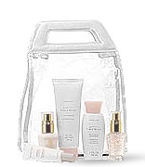
Retail
Sales

2400
-------
2200
------
2000
------
1800
------
1600
------
1200
------
1000
------
800
------
600
------
400
-------
200
-------
100
Wholesale
orders

1200
-------
1100
------
1000
------
900
------
800
------
700
------
600
------
500
------
400
------
300
-------
200
-------
100




Name: ________________

Director: ______________

Number of Faces _______

Number of Basics _______

Retail Sales _______

Wholesale Orders _______

Number of Recruits _______

Month _______________

