THE MASCARA CLUB  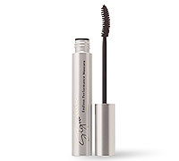  Four Mascaras a Year  Did you know that mascara must be replaced  every 3 months?  Well, worry no longer about having to remember to replace your mascara. Mascara will be delivered every 3 months.  Enroll now & get your first one FREE!  Cost: $25.50/year  Call Donna Bayes at (785) 826-1740 or go to www.marykay.com/donna to take advantage  of this program. | THE MASCARA CLUB  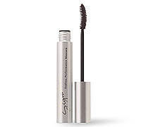  Four Mascaras a Year  Did you know that mascara must be replaced  every 3 months?  Well, worry no longer about having to remember to replace your mascara. Mascara will be delivered every 3 months.  Enroll now & get your first one FREE!  Cost: $25.50/year  Call Donna Bayes at (785) 826-1740 or go to www.marykay.com/donna to take advantage  of this program.
THE MASCARA CLUB  Four Mascaras a Year  Did you know that mascara must be replaced  every 3 months?  Well, worry no longer about having to remember to replace your mascara. Mascara will be delivered every 3 months.  Enroll now & get your first one FREE!  Cost: $25.50/year  Call Donna Bayes at (785) 826-1740 or go to www.marykay.com/donna to take advantage  of this program. | THE MASCARA CLUB  Four Mascaras a Year  Did you know that mascara must be replaced  every 3 months?  Well, worry no longer about having to remember to replace your mascara. Mascara will be delivered every 3 months.  Enroll now & get your first one FREE!  Cost: $25.50/year  Call Donna Bayes at (785) 826-1740 or go to www.marykay.com/donna to take advantage  of this program.

