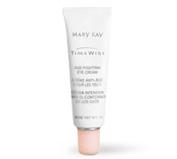
TimeWise®

Age-Fighting Eye Cream
Nine out of 10 women saw younger-looking skin.
See for yourself!

Sun, stress and fatigue can take their toll on the delicate skin around the eyes. And that's where you'll often see the first signs of aging. TimeWise® Age-Fighting Eye Cream was created specifically for the skin around the eye area and formulated to deliver anti-aging benefits.
This rich, luxurious eye cream was created to dramatically minimize the appearance of fine lines and wrinkles caused by sun, stress and fatigue.
*In a clinical study conducted by an independent laboratory, nine out of 10 women saw younger-looking skin with less-noticeable wrinkles after eight weeks.
